**Our question:** Does COVID affect post trends from mental illness related subreddits?

**Our hypothesis:** Mental health-related subreddits exhibit a shift in post trends and the number of engagements based on post texts, number of comments and upvote ratios between periods pre-covid and post-covid

Past studies that address similar topics:

1. **NLP in mental illness detection:** <https://www.nature.com/articles/s41746-022-00589-7>

* Use data from reviewed papers, social media posts constitute the majority of sources, followed by interviews, EHRs, screening surveys, and narrative writing
* Computational methods for mental health illness detection – focused on suicide, depression (types: depression, suicide, stress, anorexia, eating disorders, PTSD, bipolar disorder, anxiety, ASD, and schizophrenia) from social media and non-clinical texts
* NLP methods:
  + Machine learning methods: supervised learning → support vector machine: Adaptive Boosting (AdaBoost), Decision Trees, KNN, Random Forest, Naive Bayes, Logistic regressions; unsupervised learning → LDA topic modeling
  + Deep learning methods: embedding layer (one hot encoded vectors, BERT, ALBERT) and classification layer (CNN, RNN, Transformer-based methods and Hybrid-based methods)

#### Evaluation metrics: compare the performance of different models for mental illness detection tasks using standard evaluation metrics like Accuracy (AC), Precision (P), Recall (R), and F1-score (F1)

1. **Measuring mental health using Twitter data by ARIMA time series:** [https://academic.oup.com/jamia/article/24/3/496/2907899#google_vignett](https://academic.oup.com/jamia/article/24/3/496/2907899#google_vignette)

* ARIMA model for identifying periods of heightened activity on Twitter related behavioral health
* Understanding patterns of communication: identify hashtags related to depression or suicide
* Used natural log transformation of trends to standardize the variation of time series
* Run 2 types of forecasts: day-ahead (using full information) vs 30-day (shock period)
* Results: 5 shocks in 2014 (unexpected and expected) -> increased in activity is anticipated in response to expected shock -> study the changes for the unexpected shocks

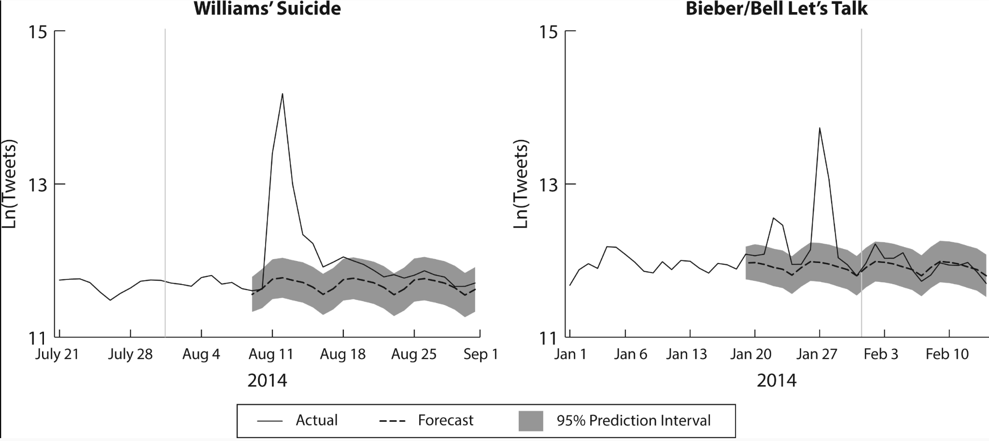

* Time series analysis + forecasting techniques → possibilities for new insights and opportunities to address public health concerns.

1. **People are increasingly more comfortable talking about mental health:** <https://www.psychiatry.org/news-room/apa-blogs/poll-american-workers-are-increasingly-comfortable>

* Workers comfortable talking openly and honestly about mental health with their supervisor or with coworkers: 51% (2019) to 62% (supervisor) and 65% (coworkers) (2020)
* People concerned about retaliation if they seek mental health care: 35% (2019) to 43% (2020)
* Employees know how to access mental health services through their employers: 70% in 2019 and 2020. However, Gen Zers (18-23 years) were significantly less likely than older generations to indicate so.
* Employees are more aware of the mental health services offered by their employer than 2020

1. **Mental Health Surveillance over social media with digital cohorts:** <https://aclanthology.org/W19-3013.pdf>

* Social media analysis concerns: bias → demographic over-represented (race, gender etc)
* Build on prior work on supervised models of mental health inference over social media
* Demographics affected individual mental illness – PTSD, depression

1. **Quantifying Mental Health Signals in Twitter:** [https://aclanthology.org/W14-3207.pd](https://aclanthology.org/W14-3207.pdf)

* Focused on PTSD, depression, bipolar disorder and SAD
* Demonstrate the effectiveness of automatically derived data by showing that statistical classifiers can differentiate users with different mental health disorders
* LIWC → measure deviations in each illness group from control
* Diagnosed group: statement to seek support from others in social network
* Control group: randomly select 10k usernames who posted a selected two week window
* Methods: quantify via automated methods: replicate previous findings, build classifiers to separate diagnosed from control users introspect on those classifiers
* Result: statistically significant difference between control and diagnosed users (LIWC), train log linear classifier, Pearson’s r correlations between various analytics